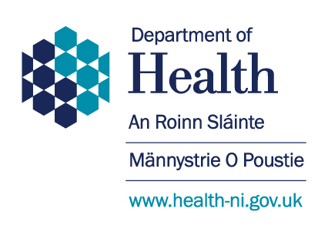

**Memorandum of Understanding Between**

**The Department of Health (NI)**

**and**

**Joint Negotiating Leads – AfC TUS**

**Introduction**

1. Following a number of meetings between Minister of Health, the Department and collective Agenda for Change (AfC) Trades Unions (TUS), a formal proposal has been tabled in respect of pay for 2024/25 for all AfC staff. This document outlines the details of the proposal.

**Pay Scales and Structures**

1. Pay for 2024/25:

* The Department accepts the need for ongoing pay parity with England.
* The recommendation of the NHSPRB of an uplift to 2023/24 pay scales of 5.5% is accepted.
* Due to current financial constraints, the Department will proceed to implement this uplift with effect from 1 June 2024.
* The Department acknowledges that this part-year payment is not final.
* Further attempts to secure the required funding will continue, and the Minister has committed that, should funding become available within the remainder of the 2024/25 financial year, the effective date of the pay award will be amended to 1 April 2024.
* In the event that sufficient further funding does not become available during 2024/25 to meet the full year effect, the Minister has committed that any shortfall shall be addressed at an early stage of the 2025/26 financial year. This will not impact on any decisions in regard to pay awards for 2025/26.
* The recommendation of the NHSPRB to include an intermediate step point in Bands 8a – 8d is accepted.
* It is intended that the pay structures in Northern Ireland will therefore continue to replicate those in place in England for AfC staff. Details of current pay in England may be found at Annex 2 of the NHS Staff Handbook: [NHS Terms and Conditions of Service Handbook | NHS Employers](https://www.nhsemployers.org/publications/tchandbook)
* The Minister has also outlined a commitment that, all things being equal, the recommendations of the NHSPRB will be accepted when published and approved for processing.